Task 2: Test log
Description of test | Test data to be used (if required) | Expected outcome | Actual outcome | Comments and intended actions
Does the website load? | URL: http://tldnc.co.uk/2025-2026/td2s/233753/puremedia-yungblud-website/ | The website loads and starts displaying content | The website loads and starts displaying content  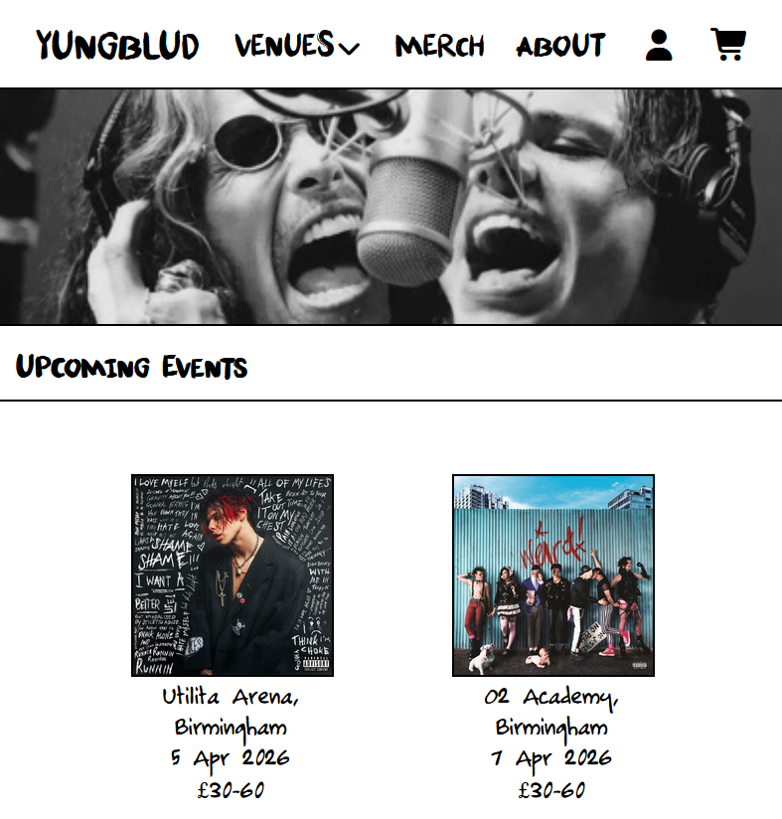 | Works as intended
Testing if the event cards have good user feedback | Hovering over an event card | The card visually pops out on hover to indicate to the user that it is interactive | The event card visually pops out on hover  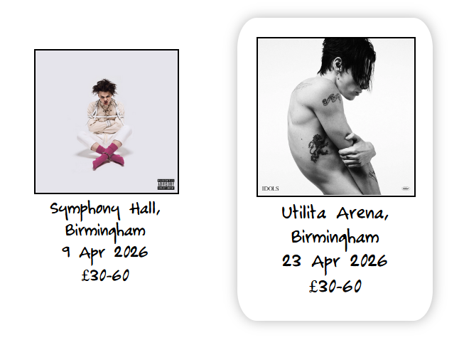 | Works as intended
Testing if the “Venues” dropdown menu opens | N/A | When clicked, the “Venues” dropdown appears | The “Venues” dropdown appears, containing links to pages for each venue  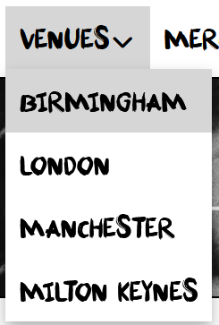 | Works as intended
Testing if the buttons in the “Venues” dropdown correctly redirect to their corresponding pages | Clicking on the “Birmingham” venue | The website loads a page containing all events happening at the Birmingham venue | The website successfully loads the Birmingham page, only displaying relevant events  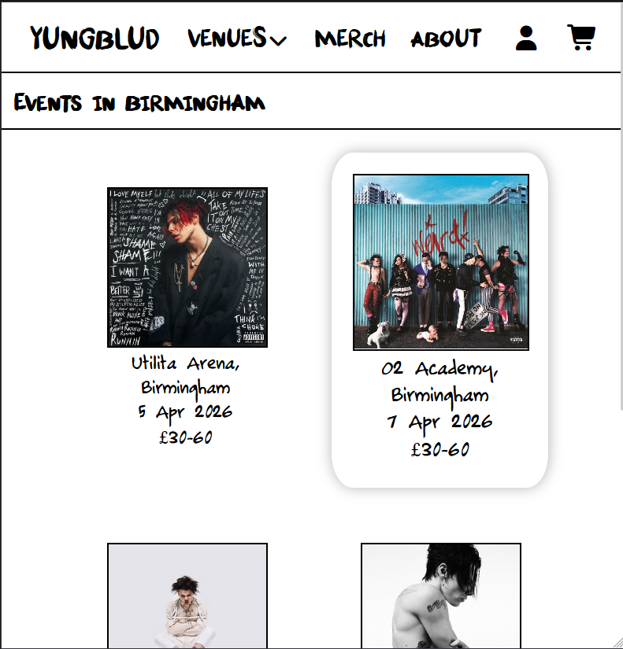 | Works as intended
Testing if other venues pages display correctly | Clicking on the “Milton Keynes” venue | The page loads correctly, with correct formatting | The page loads successfully with correct formatting  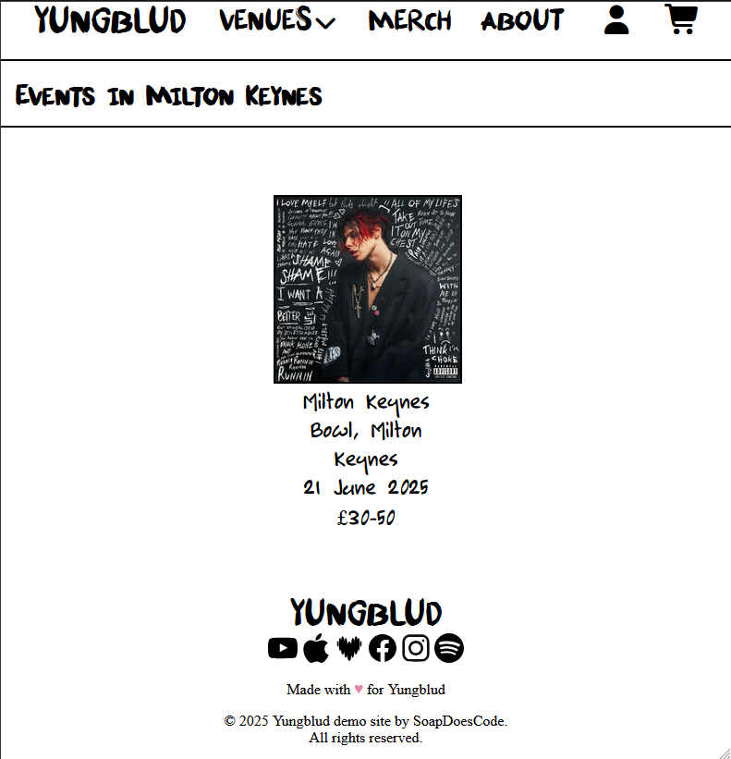 | Works as intended
Testing if the accounts page loads | Clicking on the accounts button on the navbar  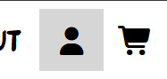 | The accounts page loads, with a form for creating an account, and another form for logging into an account | The accounts page loads, with a form for creating an account, and another form for logging into an account  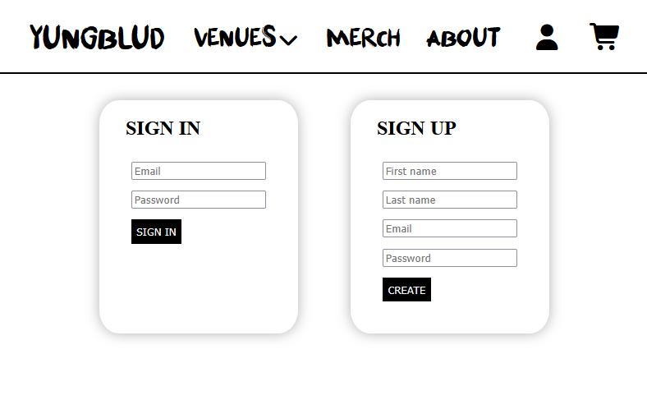 | Works as intended
Testing if the mobile version of the accounts page loads | Clicking on the accounts page with dev tools set to display as an iPhone | The accounts page loads with the sign in/register forms combined into one box, with the option to switch between the two | The accounts page correctly correctly loads with mobile formatting  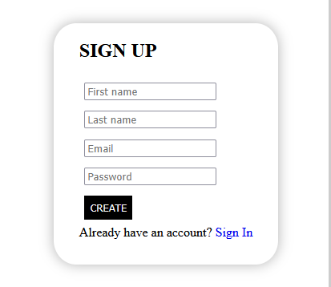  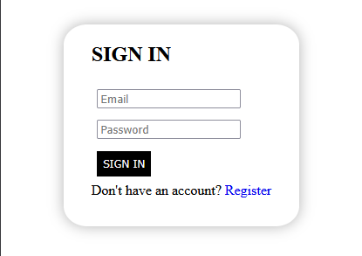 | Works as intended
Testing if the navigation bar resizes correctly on mobile | Setting the browser’s dev tools to display as an iPhone | The navigation bar switches from a horizontal to a vertical layout to better fit to a mobile screen | The navigation bar switches from a horizontal to a vertical layout  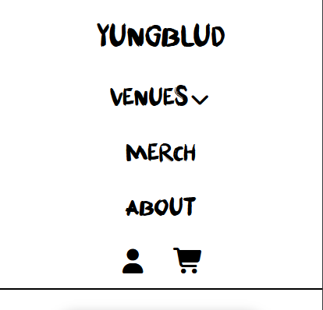 | Works as intended
Testing if the footer links work | Clicking on a link in the page footer | The corresponding social media/music platform will open in a new tab | The social media/music platform opens onto Yungblud’s profile in a new tab  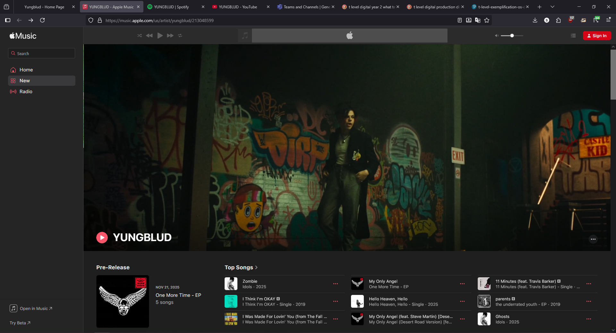 | Works as intended
Reading through the project directory structure | N/A | All assets are named and labelled correctly | One of the banner videos is incorrectly named “ozzy-osbourne.webm” | I have incorrectly identified a person in the video as Ozzy Osbourne who is actually Steven Tyler from Aerosmith. The file and all references to it have been corrected to “one-more-time.webm”

